**TUTORIAL 6 SOLUTIONS**

Q1.

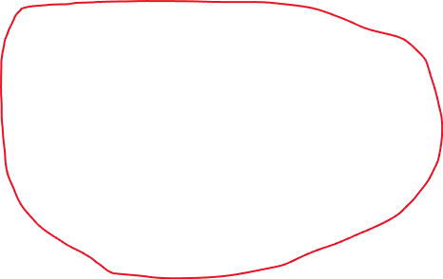

There is no need to obtain the Truth Table. One can directly go from the CSOP form to the K-map.

Q2.

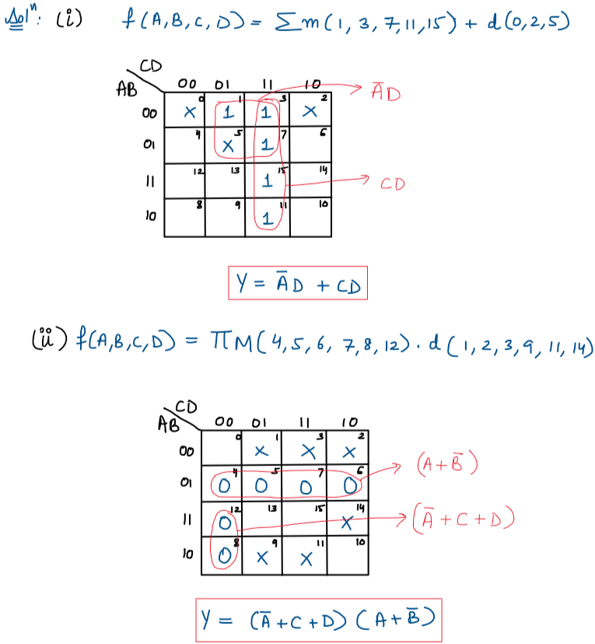

Q3

a)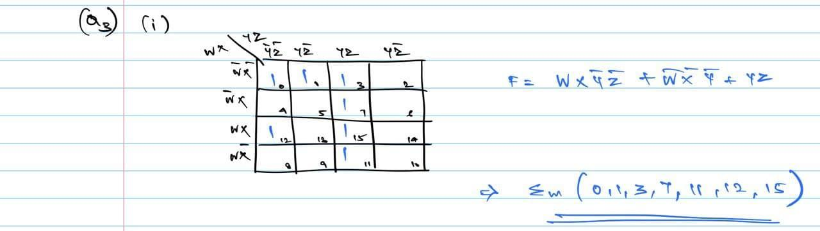



b)

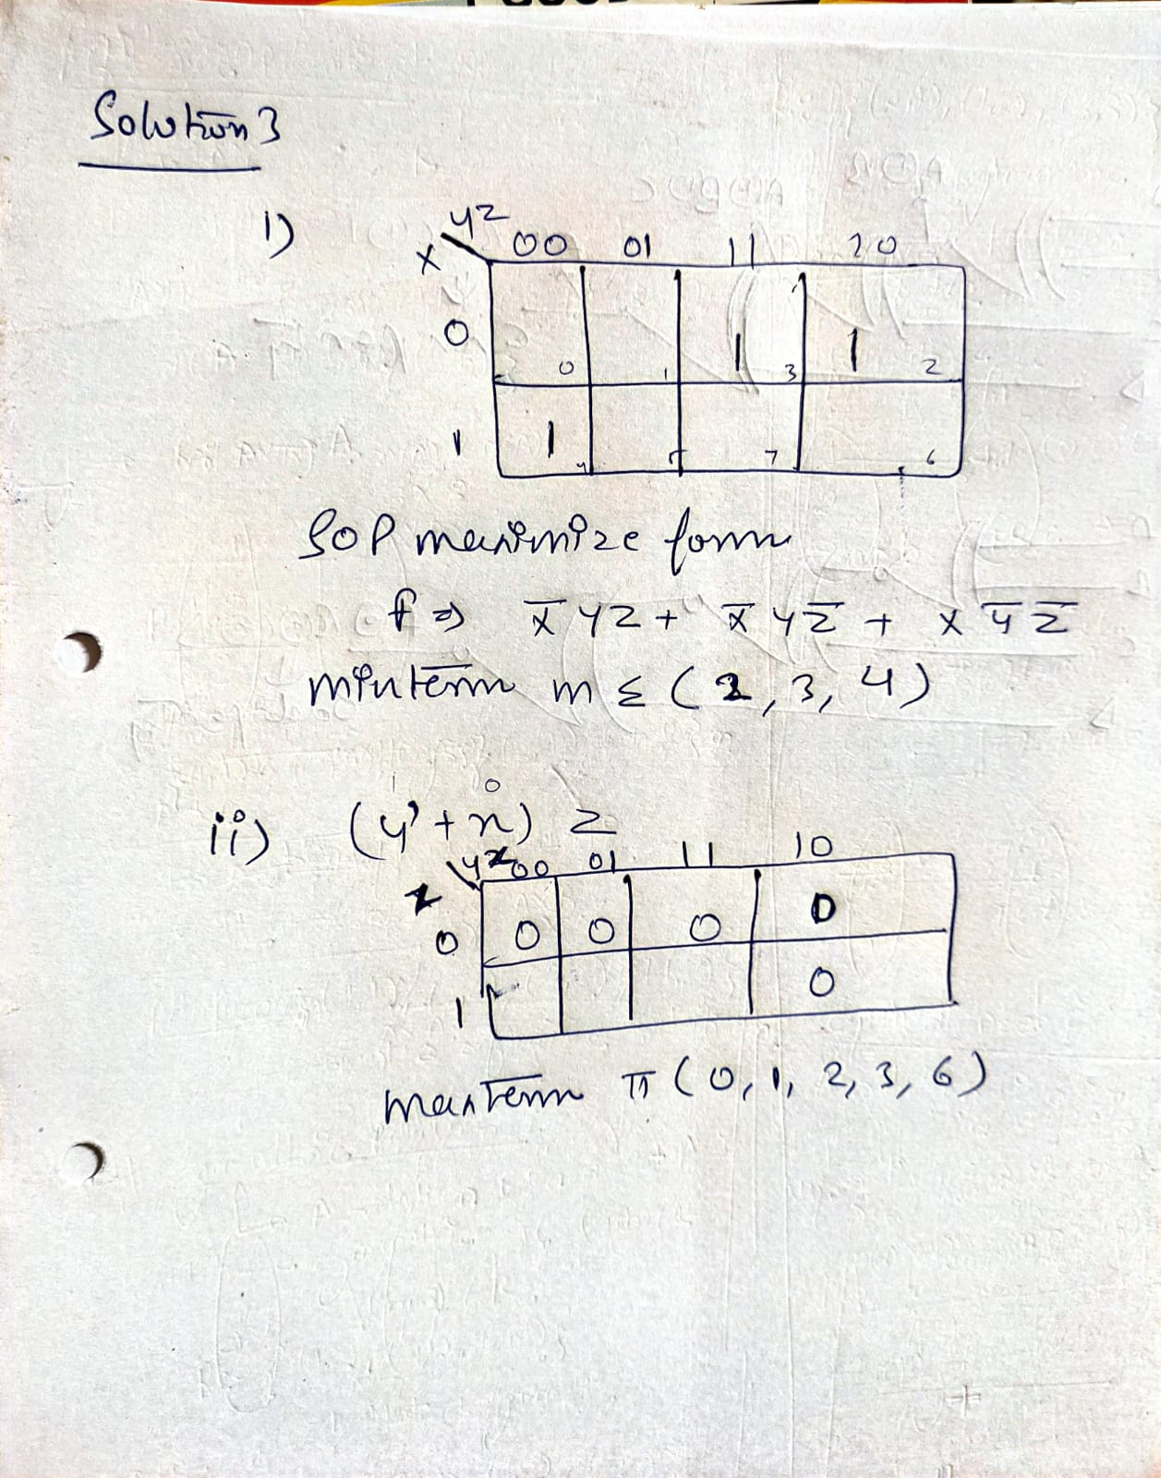



It is always a good practice to fill the K-map and not leave blank squares.

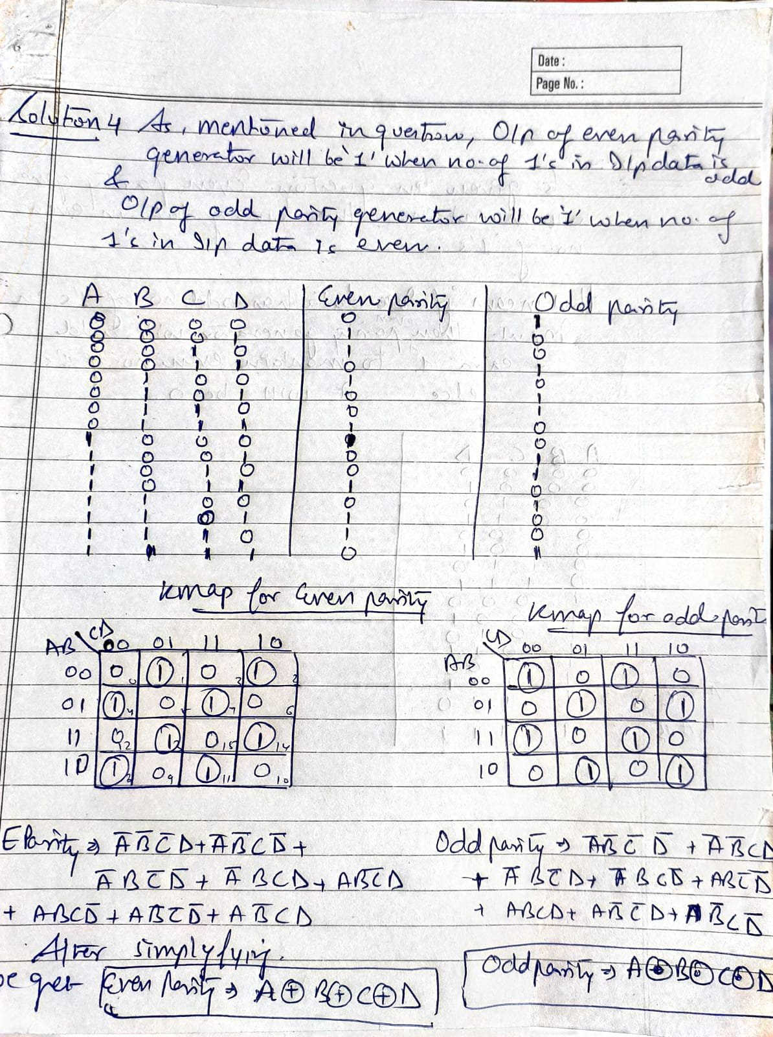Q4)

It is not essential to draw the K-map for both odd-arity and even-parity generators. If a student evaluates the expression for one of the two and obtains the other as its complement, it should be accepted.

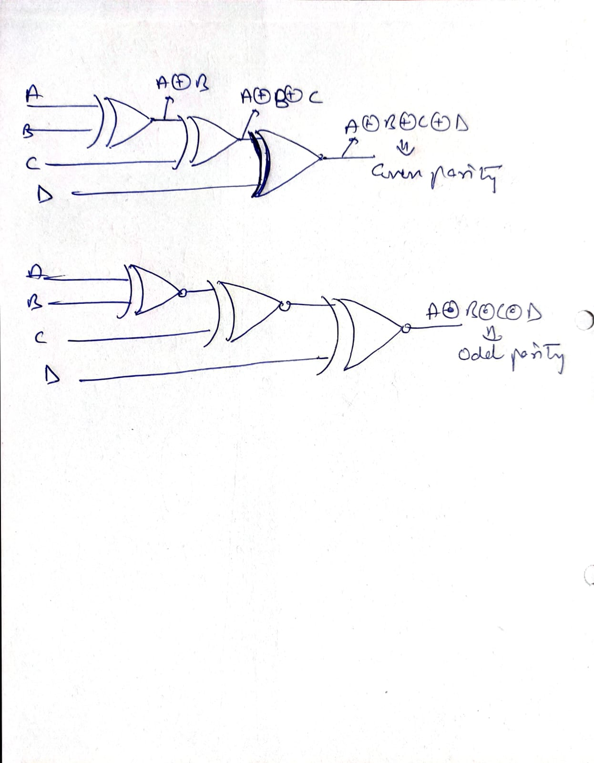

Q5:

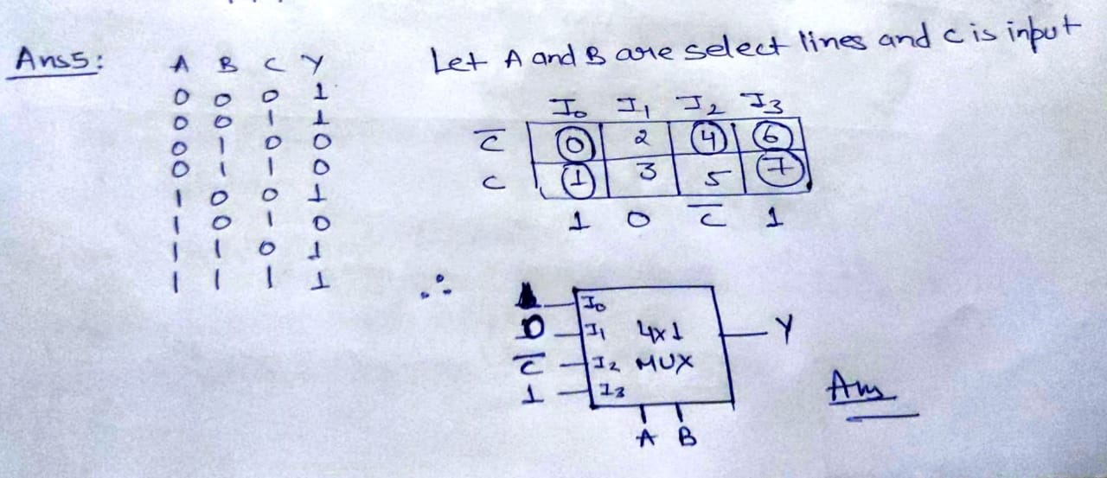

Q6)

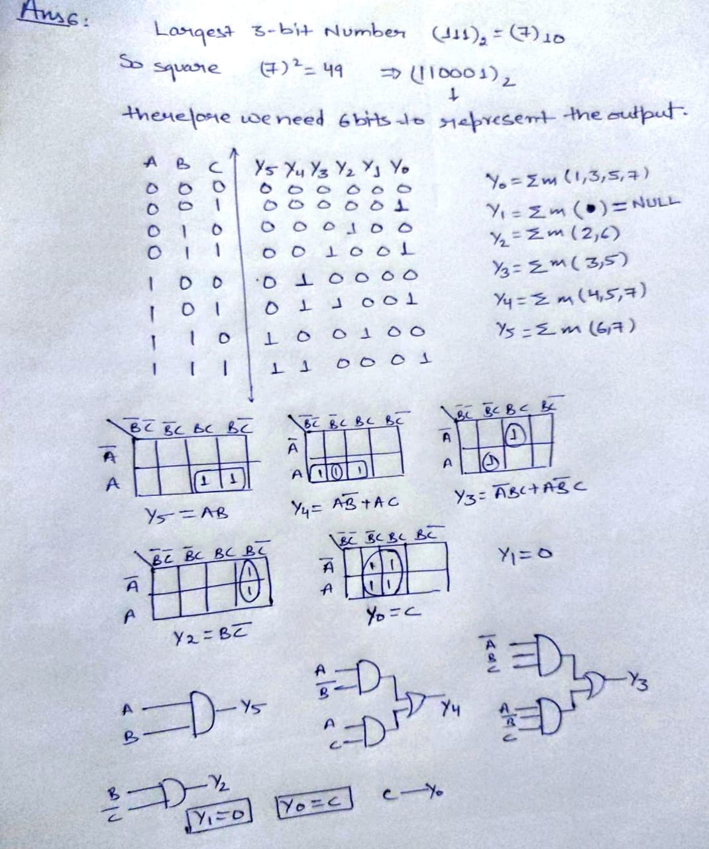

Q7)

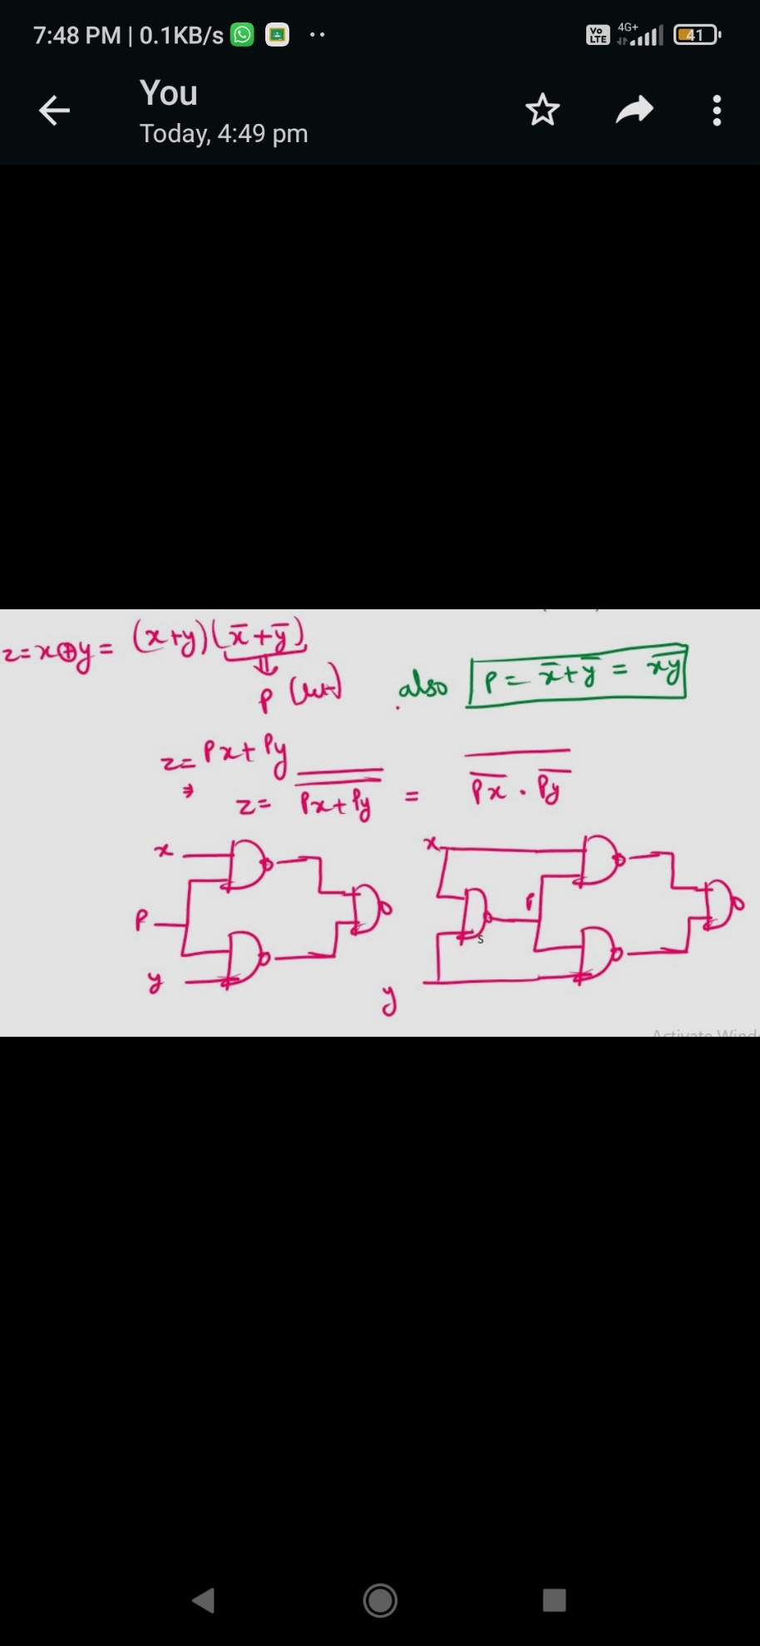

Q8)

